Git tasks

1. Install git.
Git -- version ( to the version of git )
( when we download gitbash git is by default download website)
Git init - to start the git
Git clove <ur> - git clone is used to download an entire remote repository (GitHub, GitLab, Bitbucket, etc.)

2 .Create a repo in github with README.md and .ignore file.
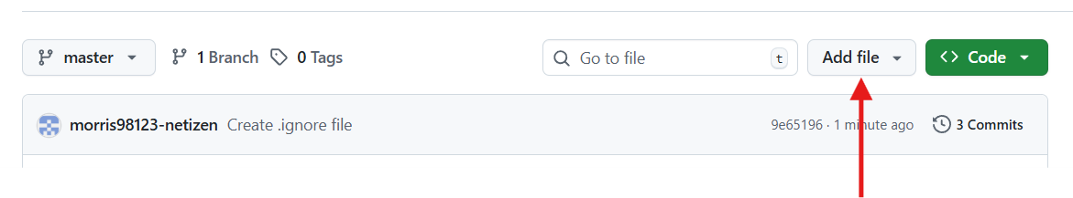
Go to repo and (add new file)

3.Clone the created repo to local.
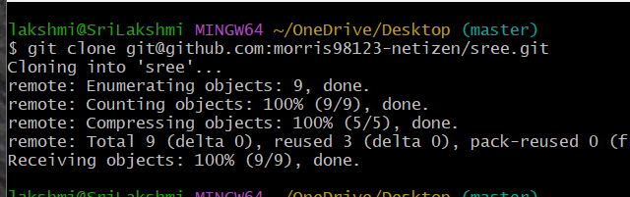
git clone <ur> - repo to local
git clone – complete details of project

4. Create two files in local repo.
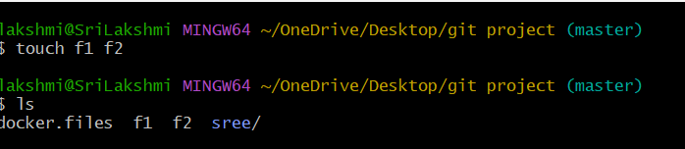
Touch f1 f2 - create a files
5.Commit two files and push to central Repository
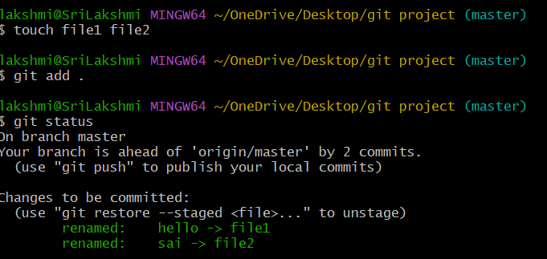
Git add . – to add the all files at a time (.)
Git status – check tracked / untracked files
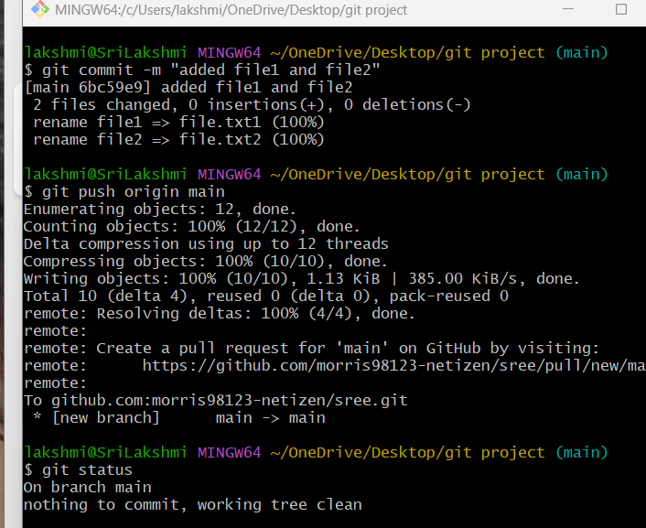
Git commit -m “message” – add the 2 files
Git puch origin main – to puch the files form local to c.repo

6 . Create a branch in local and create a sample file and push to central.
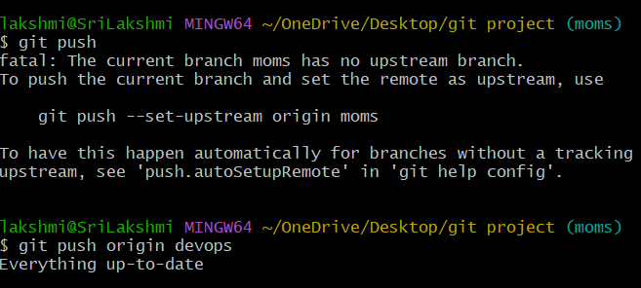
Git push – push the code
Git push origin devops – push the code
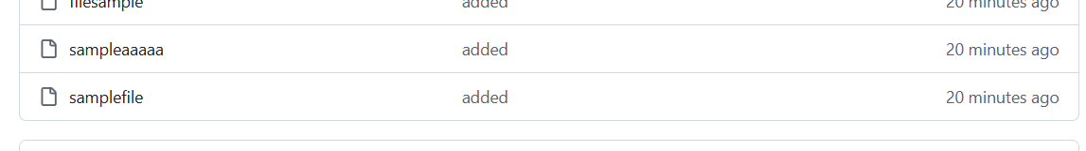
Create a file

7. Create a branch in github and clone that to local.
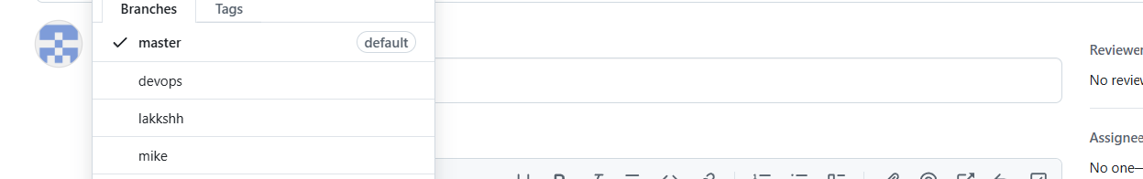
git@github.com:morris98123-netizen/sree.git
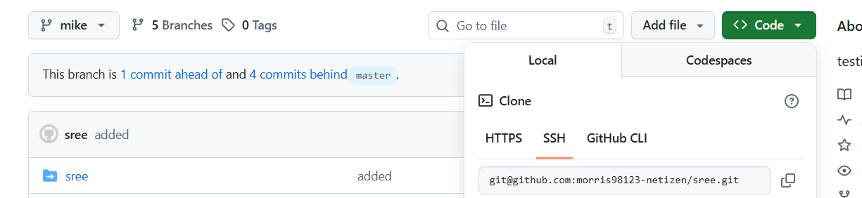
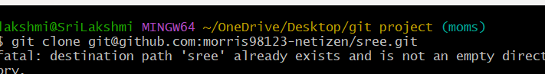

8 . Merge the created branch with master in git local.
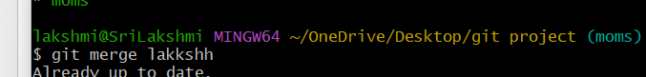
Merge the branch
9.Merge the created branch with master in github by sending a pull request.
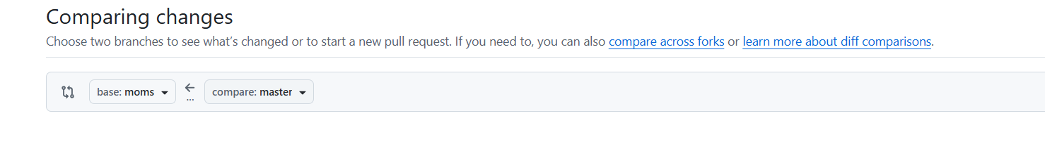

I have merged the created branch with master by sending apull request and merging

10. Create a file in local and send that to branch in github.
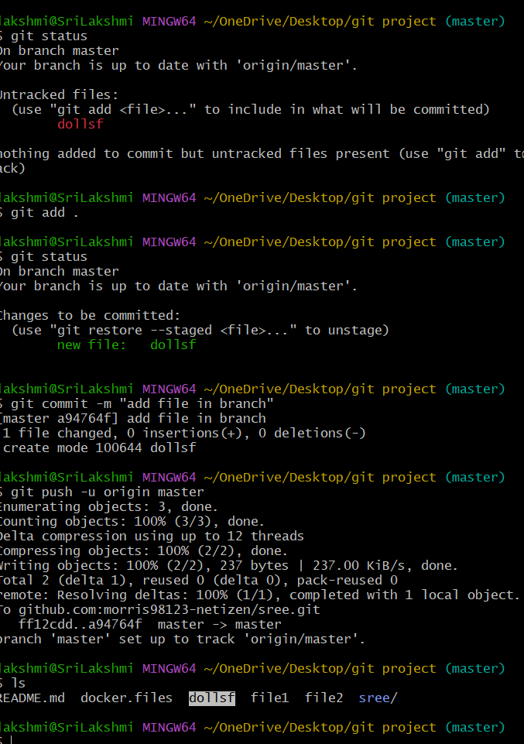
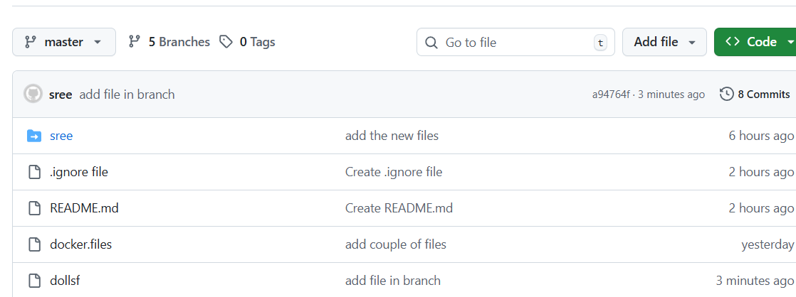
Touch file
Git statud
Git commit -m
Git push -u origin <branch>
View in github

11.Clone only a branch from github to local.
Create a one new branch in github after that coming to local and clone the new branch into local
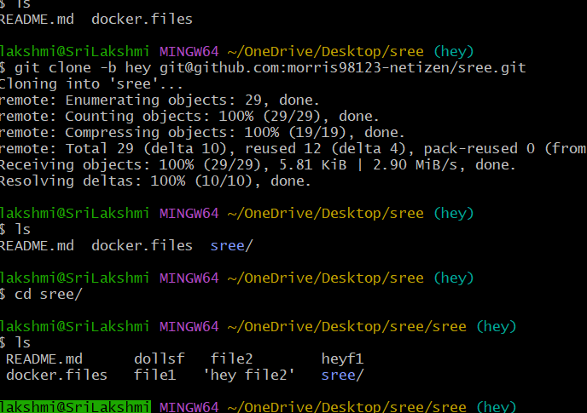
Git clone -b <branchname> - this command used only one branch from github to local.

12. Create a file with all passwords and make that untrackable with git.
Vi password – create a files /vi .gitignore – aother file create
Git add .gitignore
Git commit -m “message”
Git push
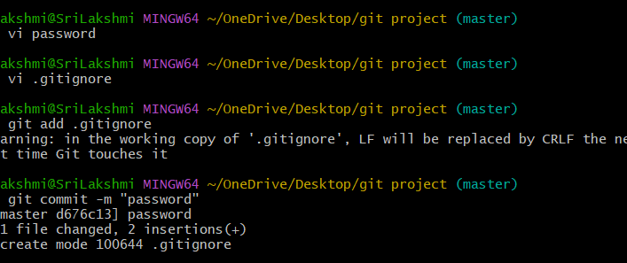
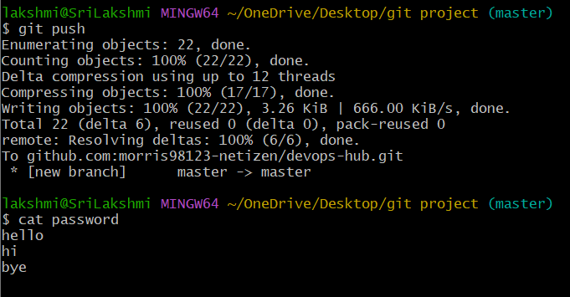
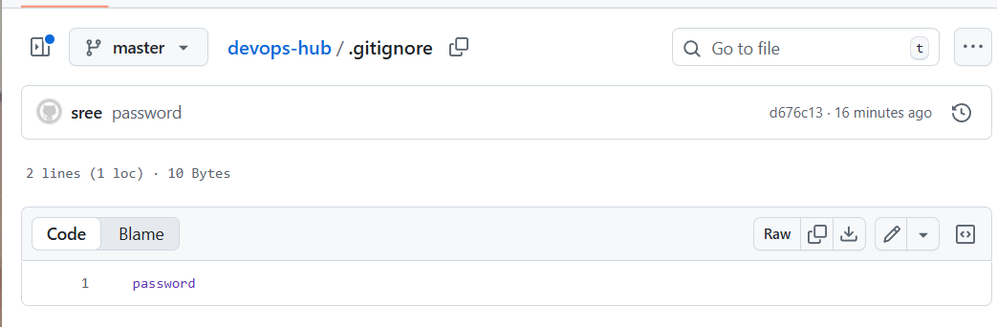

13. Make a commit and make that commit reset without savings changes.
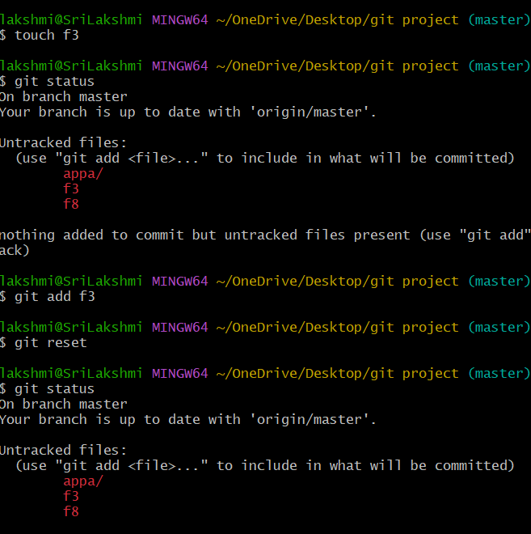

14 Git revert – move files form tracking to untracking area

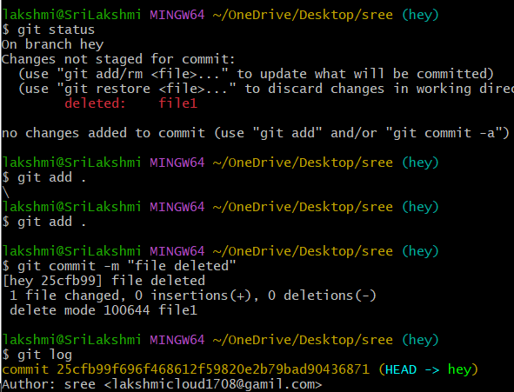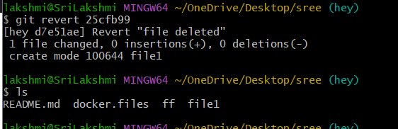
Git revert (id) - We can get back the deleted file to local repository

15. Push a file to stash without savings the changes and work on another file.
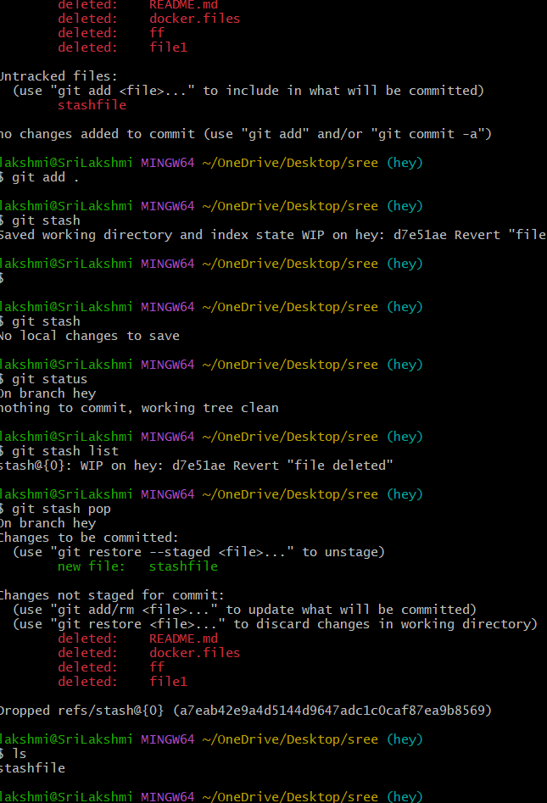
Stash - To temporarily store your changes without committing
Git stash

16.Undo the stash file and start working on that again.
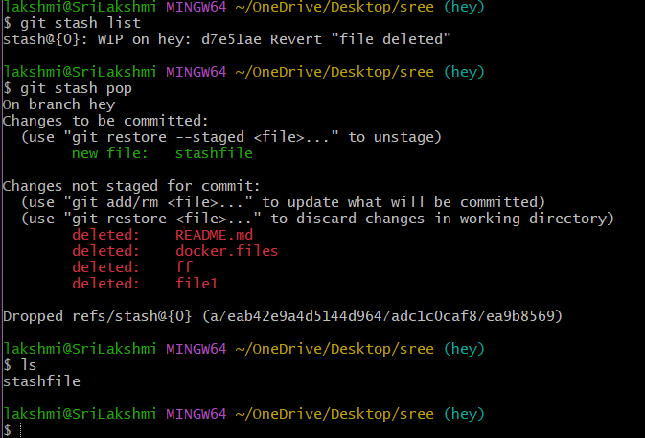

Git stash pop – it will help to get the stash file form stash memory
17.Generate a ssh-keygen and configure into GitHub.

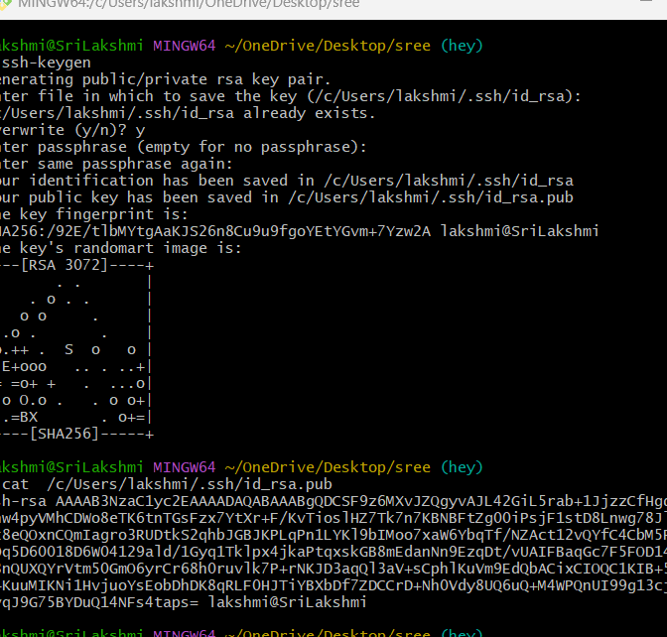
19. Basic understanding of .git file.
Without .git we cannot commit and push the file or changes of the code to central repo.
20. Check all the logs of git.

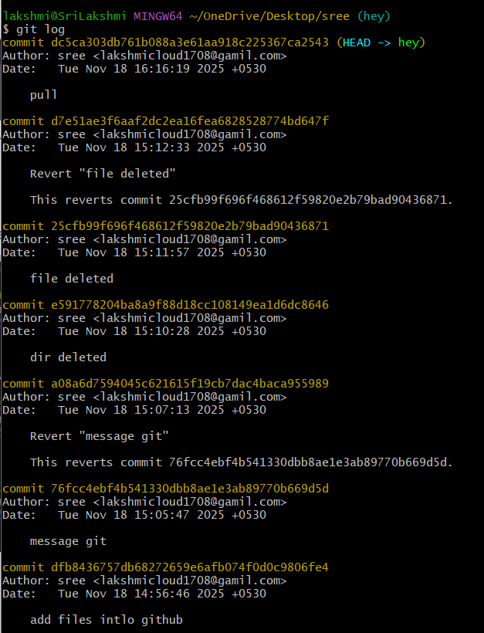

21. Rename the commit message
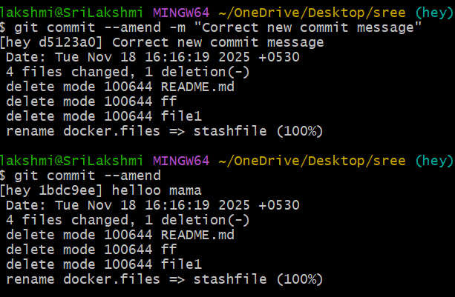
Git commit –amend - it help to change the commit message
22. Merge multiple commits into single commit.
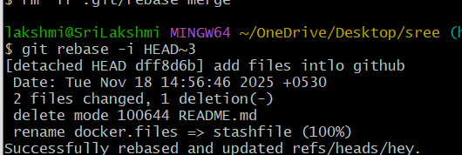

After you will get the output as successful as like below and check the logs to verify
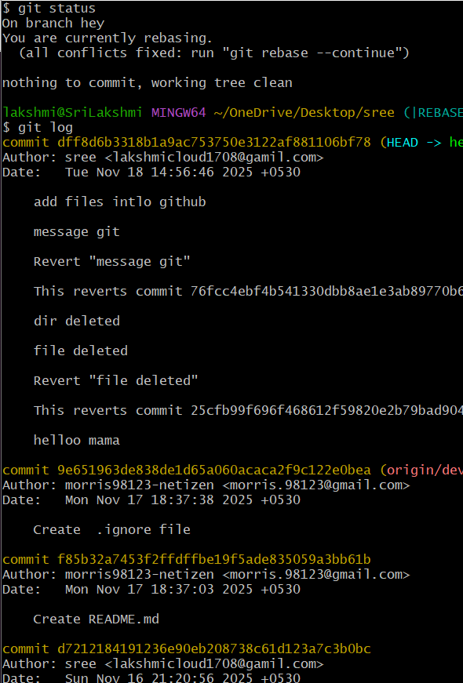
Check logs using git command to verify the recently merged

